

|  |  |  |  |  |  |
| --- | --- | --- | --- | --- | --- |
|  | | | | | |
|  | User Manual for InnerWorksCounselling.com.au | | | |  |
|  |  | | |  | |
|  | |  |  | | |
|  | | **Prepared by**   * Tong Lan (24056082) * Lucy Chen (21978612) * Kazi Imran (23846485) * Luna Zhang (23807749) * Raul Poma Astete (23958495) * Konstantin Tagintsev (24090236)   15/09/2024  v1.0 |  | | |

Table of Contents

User Manual for InnerWorksCounselling.com.au 1

How to Edit the Front/Home Page Content 3

How to Edit the About Page Content 7

How to Edit the Services Page Content 12

How to Edit the Resources Page Content 15

How to Add, Edit and Delete a Resource 19

How to Edit the Contacts Page Content 21

Chat bot 25

Contacts table 29

# How to Edit the Front/Home Page Content

1. **Log in to the WordPress Dashboard**

* 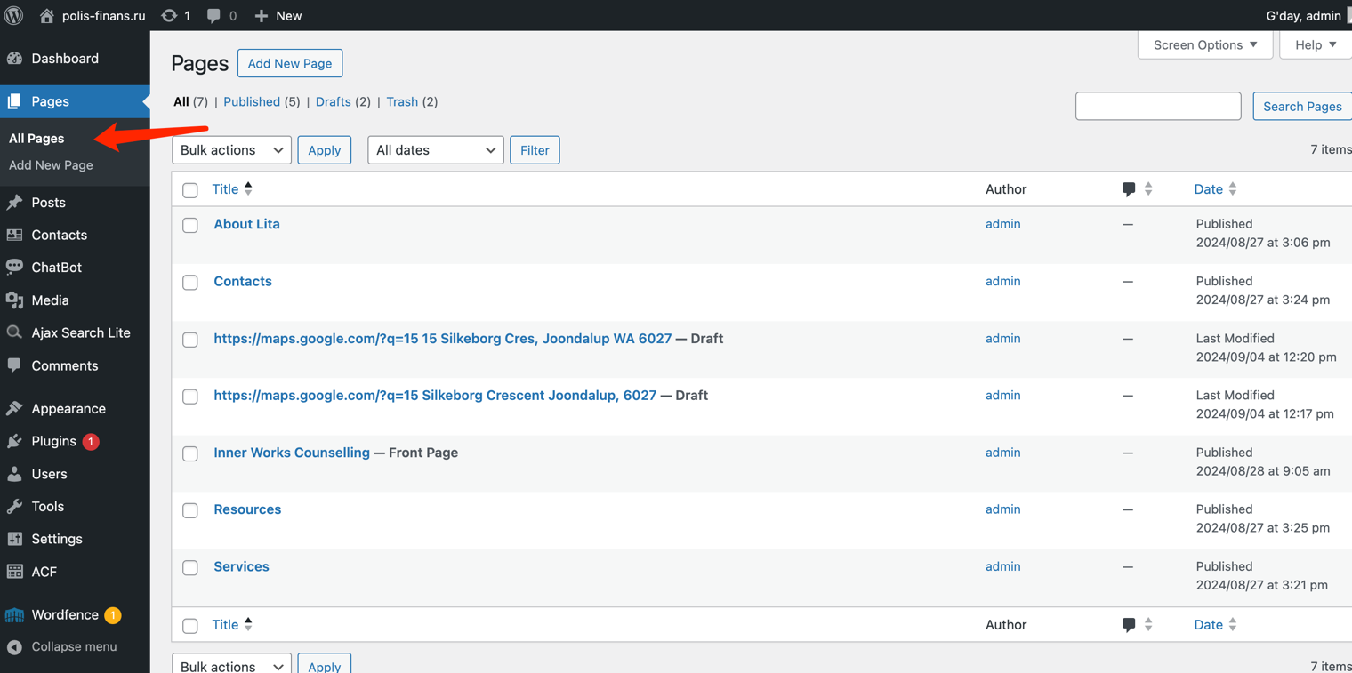On the left sidebar menu, click on "Pages – All Pages".

1. **Select the ‘Front page’ to Edit**

* 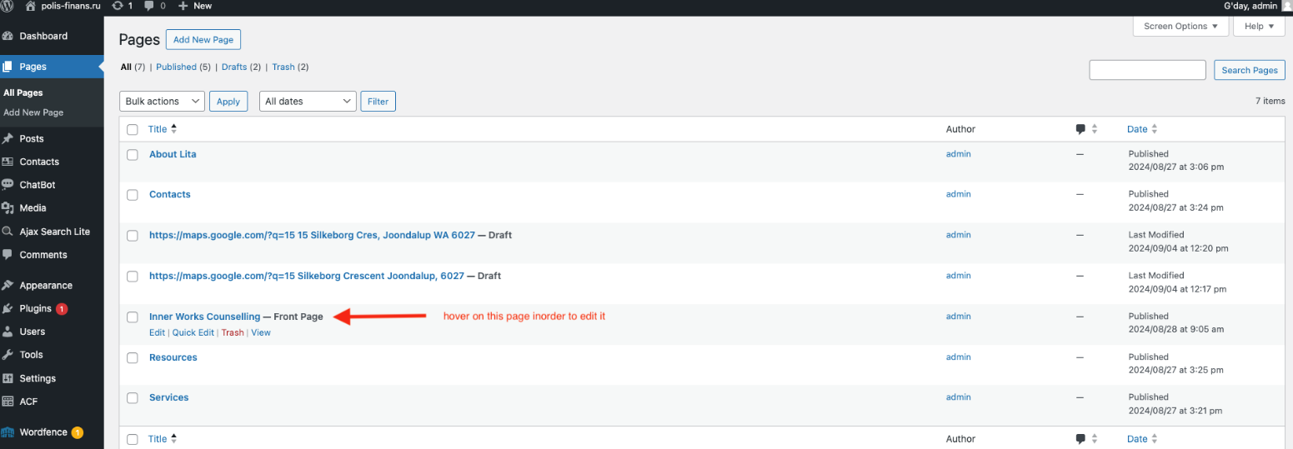On the Pages screen, locate the "Front page" page in the list of pages. Hover your mouse over the "Front" page title and click "Edit" when it appears.

1. **Edit the content**

* By using page editor, title and content can be changed simply clicking on the paragraph you want to modify.

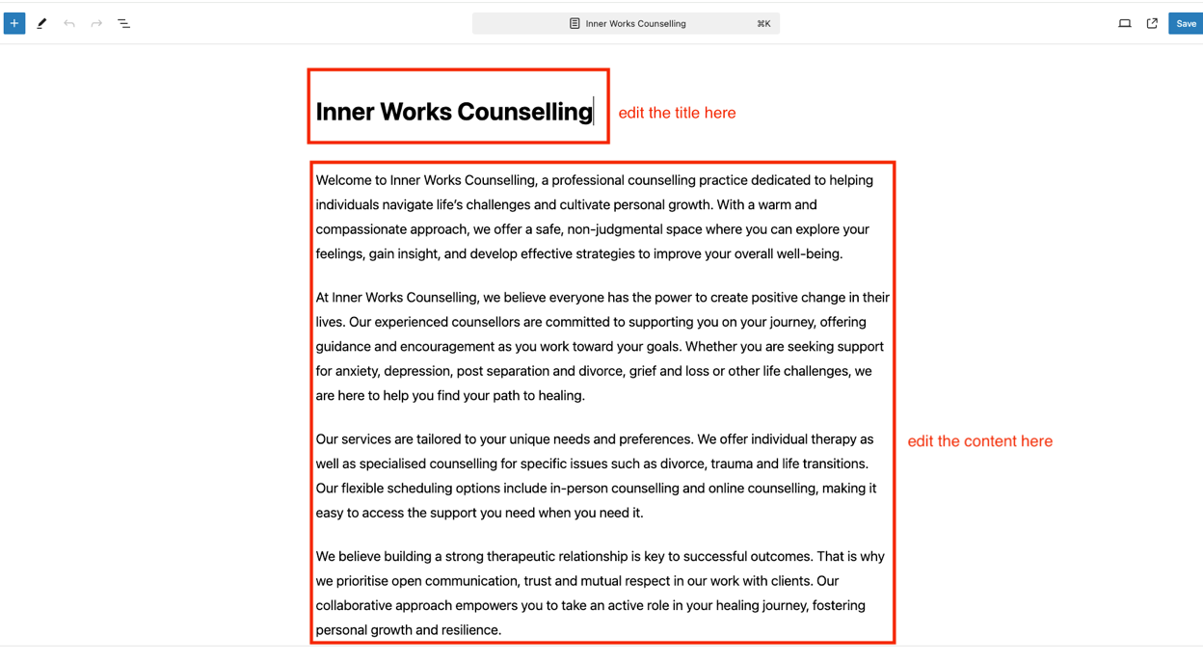

* Use toolbar to format your text when editing content.

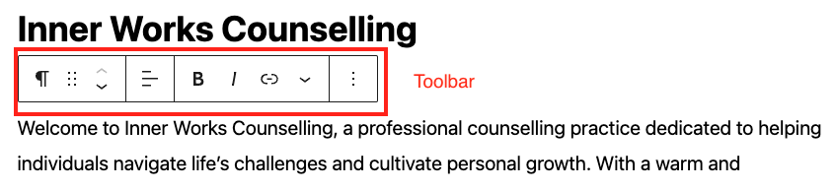

**4. Edit text in the header**

* To edit the text in the header as per the screenshot below, scroll down to the bottom of the page.

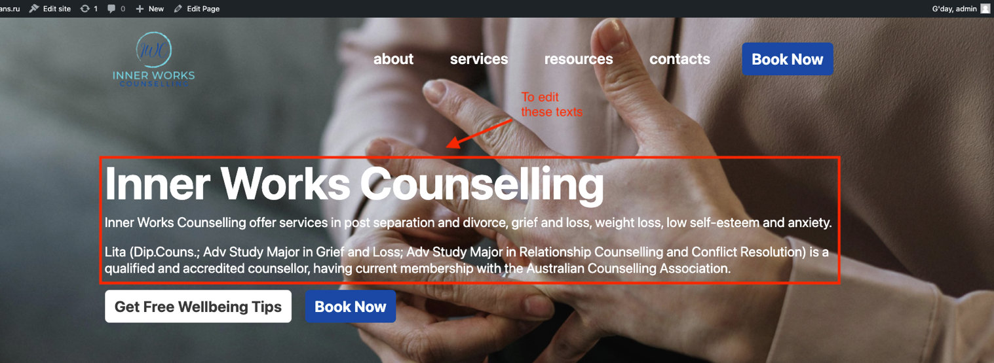

* 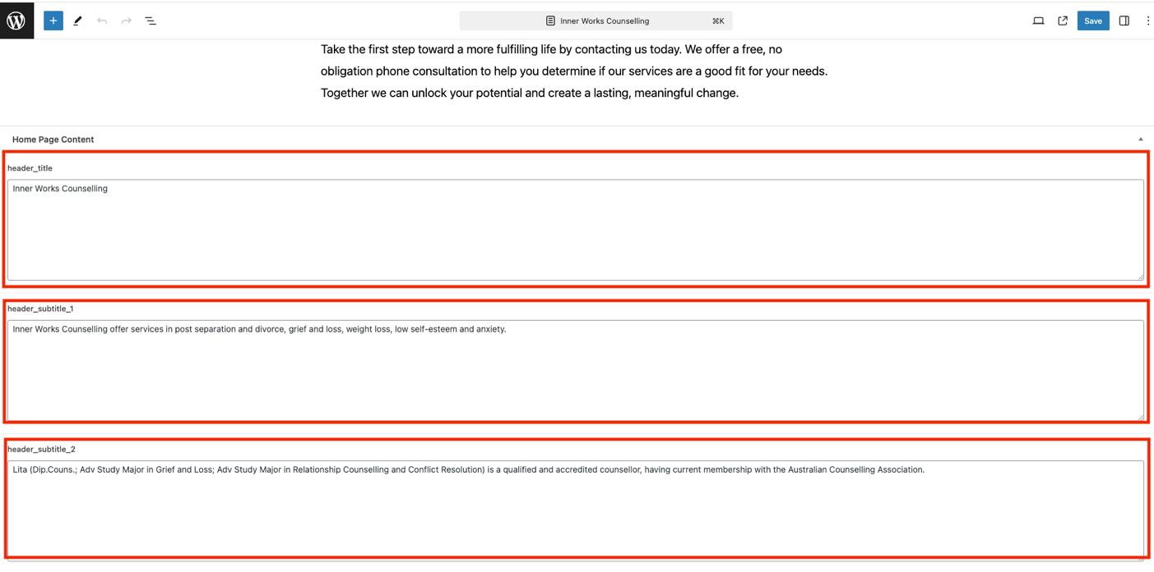Text in these 3 containers will appear in the header.

**5. Adding new content**

* Click on the “+” icon on the top left of the editor to add new blocks e.g. paragraphs, headings, images, etc.

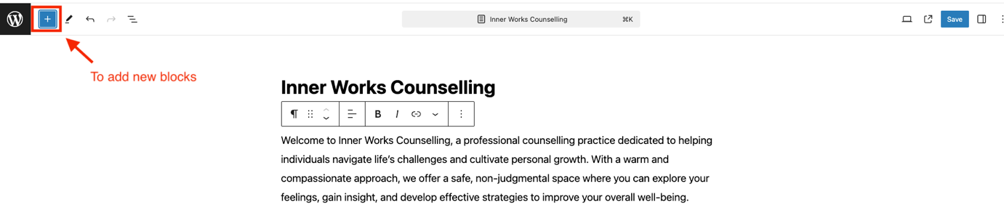

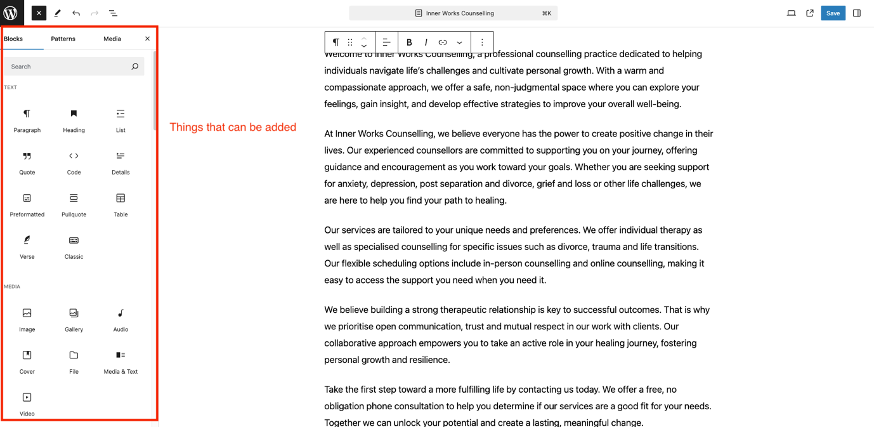

**6. Preview and Save Changes**

To preview your changes, click the laptop icon in the top right corner. This opens a dropdown menu with several options:

* Desktop: Preview how the page looks on desktop screens.
* Tablet: Preview the page layout for tablet devices.
* Mobile: See how the page appears on mobile phones.
* Preview in new tab: Opens a full preview of the page in a new browser tab.

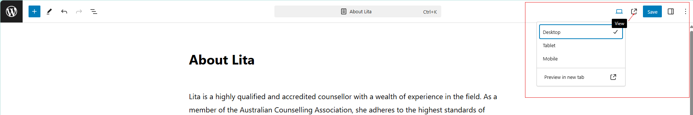

After previewing, click the "Save" button to publish your updates. Visit your website to verify the changes appear as intended.

# How to Edit the About Page Content

**1. Log in to WordPress Admin Panel and Navigate to Pages**

Log in to your WordPress admin dashboard. In the left sidebar menu, click on "Pages – All Pages".

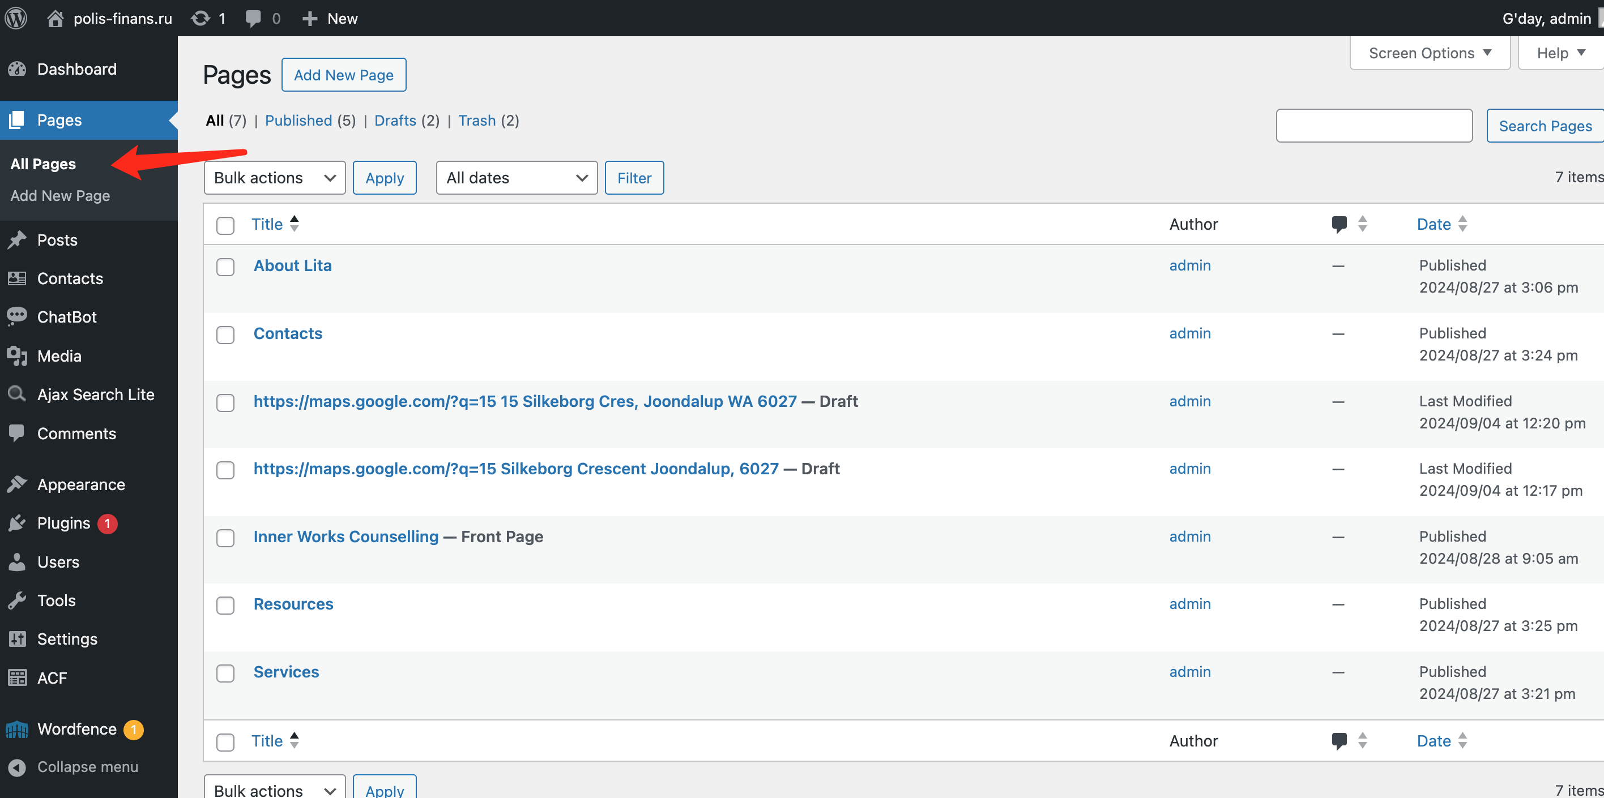

**2. Locate and Edit ‘About’ Page**

On the Pages screen, locate the "About Lita" page in the list of pages. Hover your mouse over the "About Lita" page title and click "Edit" when it appears.

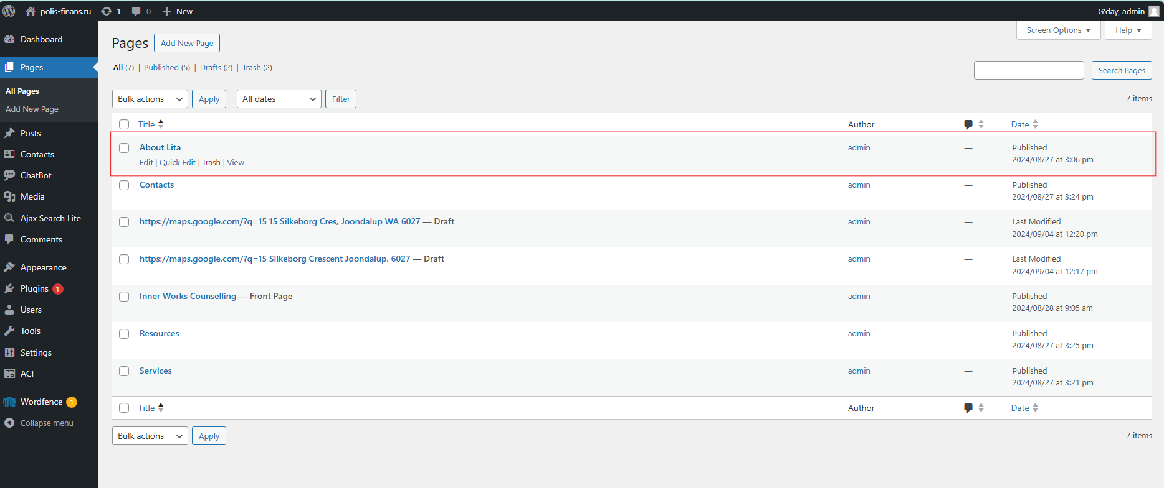

**3. Edit / Add Content Existing Fields**

The page editor will allow you to change the following fields:

* **Title**: Change the title by editing the text in the title field at the top.
* **Main Content**: Scroll down to the content editor. Here, you can edit the text, add new paragraphs, or format existing content.

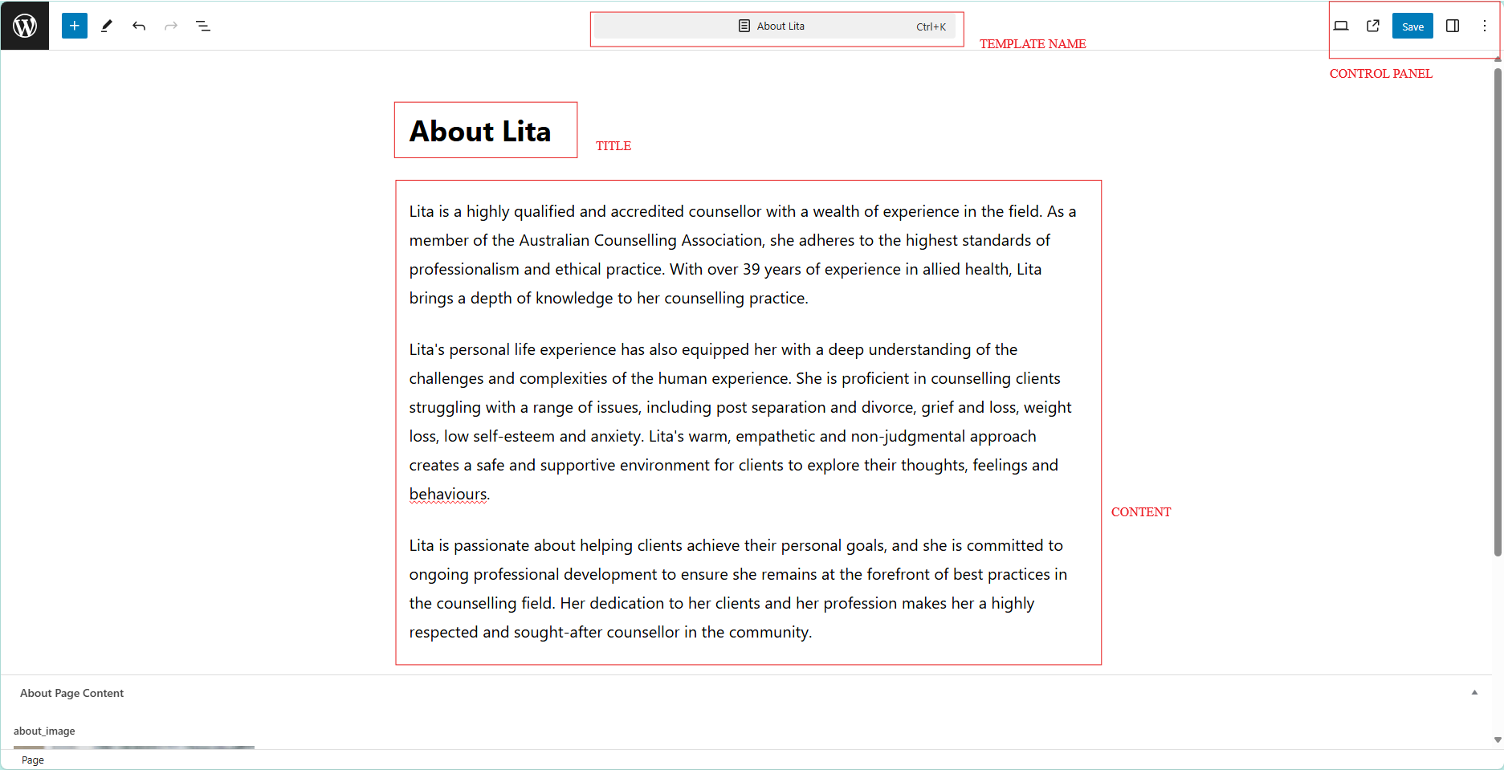

* **Edit Image**: To edit the image, scroll down then click on the existing image and click the pencil icon to edit. It is possible to edit information about the image.

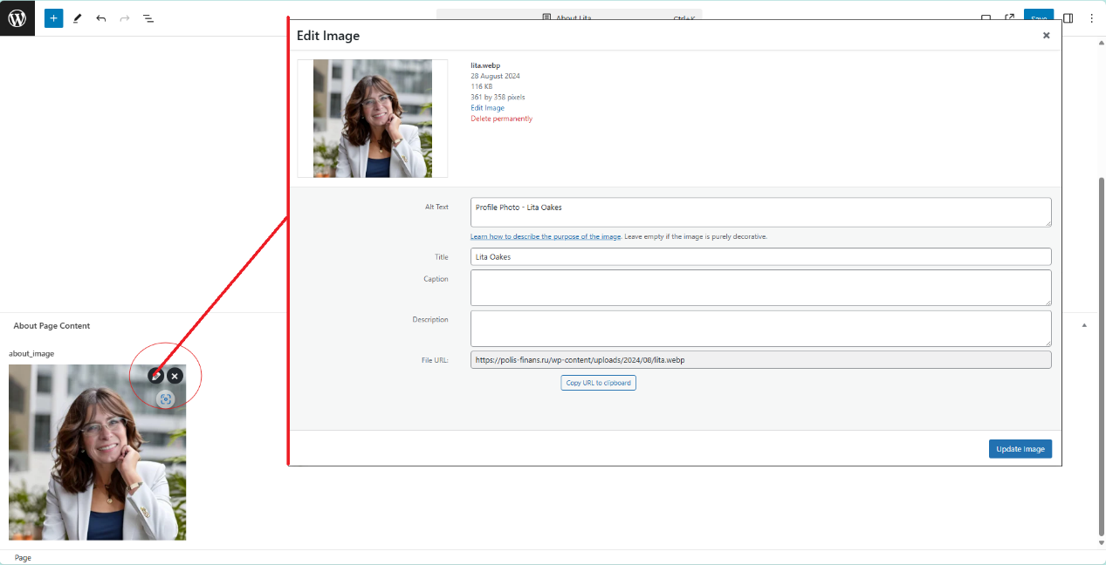

* **Replace Image**: To edit the image, scroll down then click on the existing image and click the x icon to remove the current image. It is possible to Upload a new image or select one from the media library.

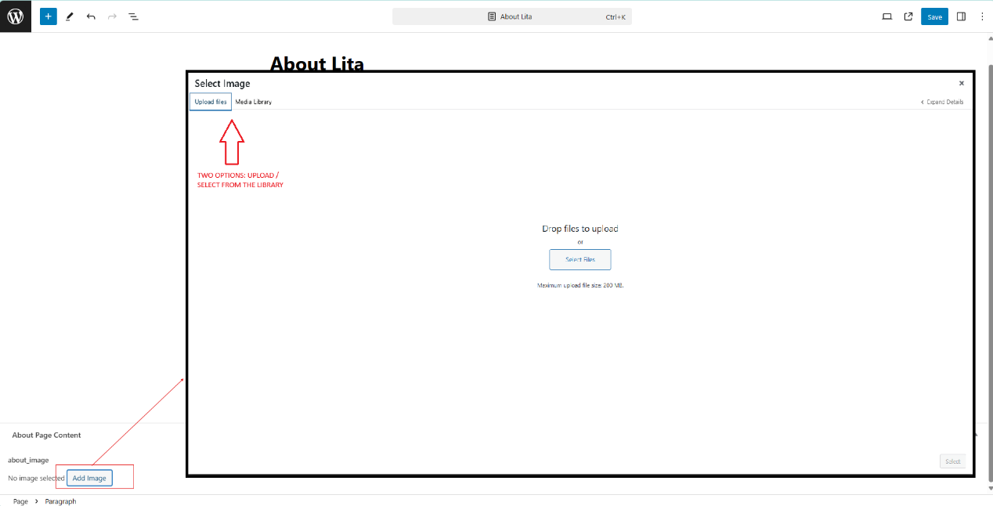

**4. Edit the content**

* Click on the paragraph you want to modify.
* Use the text editing toolbar that appears above the paragraph to format your text (bold, italic, link, etc.)
* Type or paste your new content directly into the paragraph block.

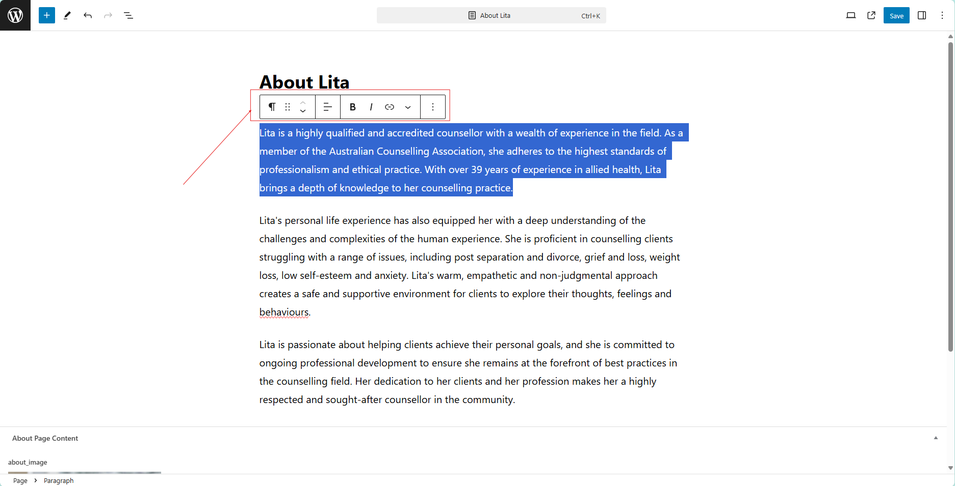

**5. Add new content**

* Click the "+" icon at the top left of the editor to add new blocks (like paragraphs, headings, images, etc.)



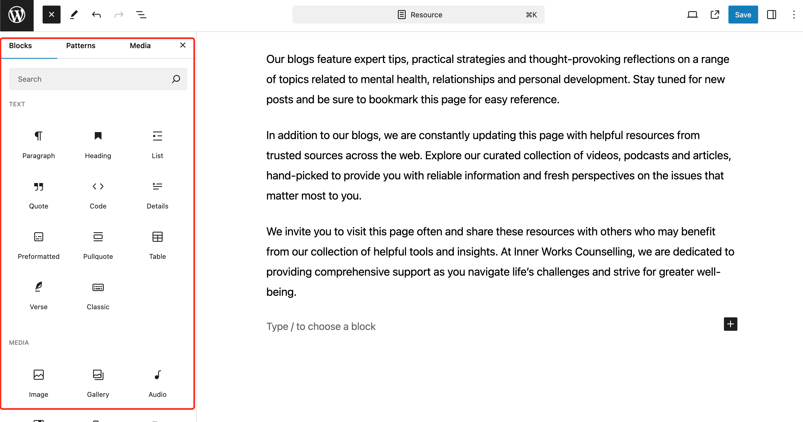

**6. Preview and Save Changes**

To preview your changes, click the laptop icon in the top right corner. This opens a dropdown menu with several options:

* Desktop: Preview how the page looks on desktop screens.
* Tablet: Preview the page layout for tablet devices.
* Mobile: See how the page appears on mobile phones.
* Preview in new tab: Opens a full preview of the page in a new browser tab.



After previewing, click the "Save" button to publish your updates. Visit your website to verify the changes appear as intended.

**7. Rollback**

If you are not happy with your changes or you want to undo or redo changes, there is a edit panel bar in the left side of the page with tools such as:

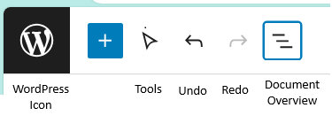

* Tools: Tools provide different interactions for selecting, navigating, and editing blocks. Toggle between select and edit by pressing Escape and Enter.
* Undo
* Redo
* Document Overview

Note: if you want to just quit without saving, just click on the WordPress Icon and confirm you want to not save your changes.

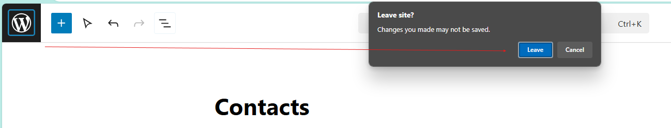

# How to Edit the Services Page Content

**1. Log in to WordPress Admin Panel**

* Go to your admin dashboard.
* Enter your admin credentials to log in.

**2. Navigate to the Pages Section**

* In the left sidebar menu, click on **Pages > All Pages**.



**3. Locate and edit the ‘Services’ Page**

* On the **Pages** screen, find the **Services** page in the list of pages.
* Hover over the **Services** page title and click **Edit**.

**4. Edit the Content of the Services Page**

* **Edit the Title:**
  + At the top of the page editor, you’ll see the title field.
  + Click the title field to edit the current title (e.g., change "Services" to "Our Services").
* **Edit Existing Service Descriptions:**
  + Scroll down to the main content editor.
  + Click on the paragraph block containing the service description you want to modify.
  + Use the text editing toolbar above the paragraph to format your content (bold, italic, links, etc.).
  + Type or paste new content directly into the block to update the service descriptions.

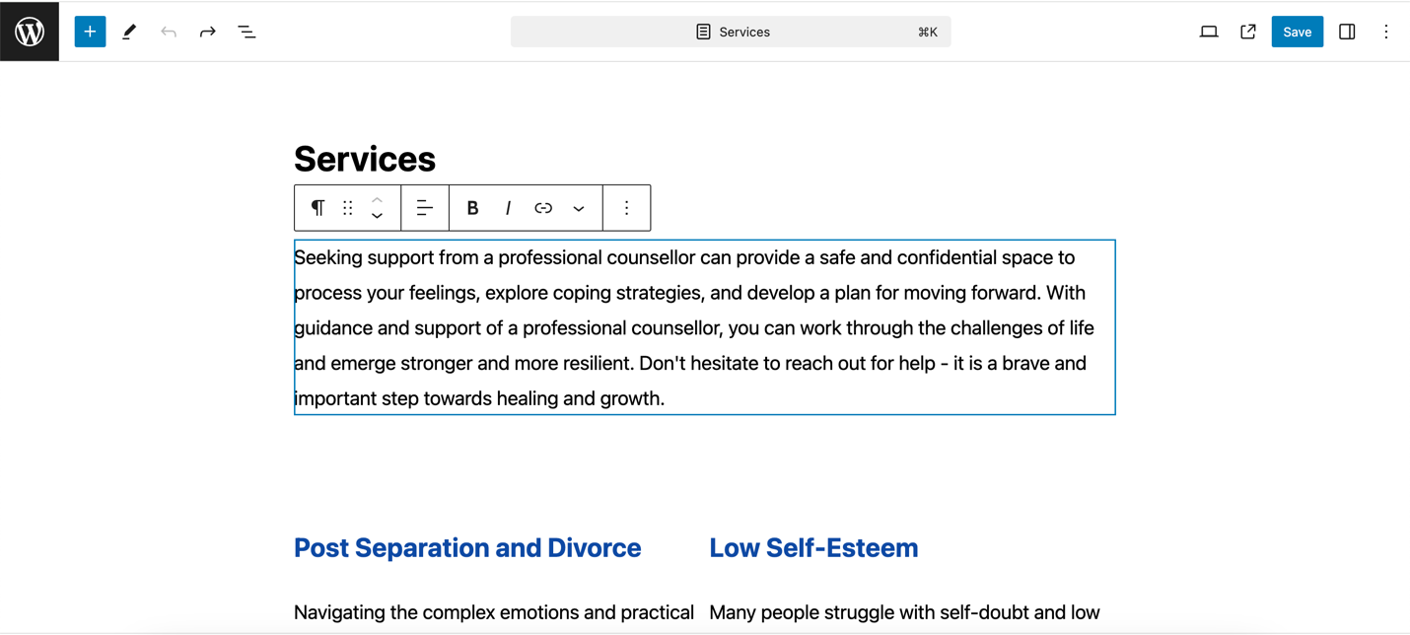

**5. Add New Service Sections (Optional)**

* To add a new service section, click on the "+" icon at the top left of the editor.
* Select the appropriate block type, such as a paragraph, heading, or image block, and add the new service content.

**6. Adding/Editing Images for Services**

* If you have images associated with services:
  + Click on the existing image to edit it, then click the **pencil icon** to modify details or the **X icon** to remove it.
  + To add a new image, select the image block, upload a new image, or choose one from the media library.
  + You can align and size the image using the toolbar that appears when you select it.

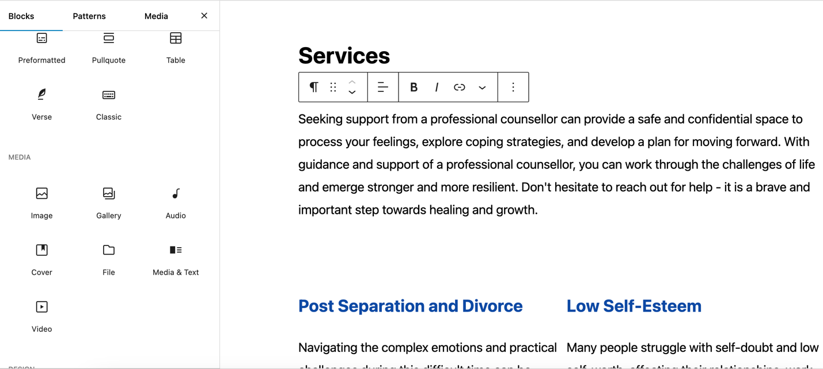

**7. Preview and Save Changes**

* **Preview:** Click the laptop icon in the top right corner to preview how the page looks across different devices:
  + **Desktop:** See how the page looks on desktop screens.
  + **Tablet:** Check how the page appears on tablet devices.
  + **Mobile:** View the mobile version of the page.
  + **Preview in New Tab:** Open a full preview of the page in a new browser tab.
* **Save:** After making the necessary changes, click the **Save** button to publish your updates.

**Step 8: Rollback Changes (Optional)**

* If you are not happy with the changes you made, or want to undo or redo changes:
  + Use the undo/redo icons in the toolbar at the top of the editor.
  + If you want to discard changes and quit without saving, click the **WordPress icon** at the top left and confirm that you do not want to save changes.

# How to Edit the Resources Page Content

1. Log in to your WordPress admin dashboard. In the left sidebar menu, click on "Pages – All Pages".



2. On the Pages screen, locate the "Resources" page in the list of pages. Hover your mouse over the "Resources" page title and click "Edit" when it appears.

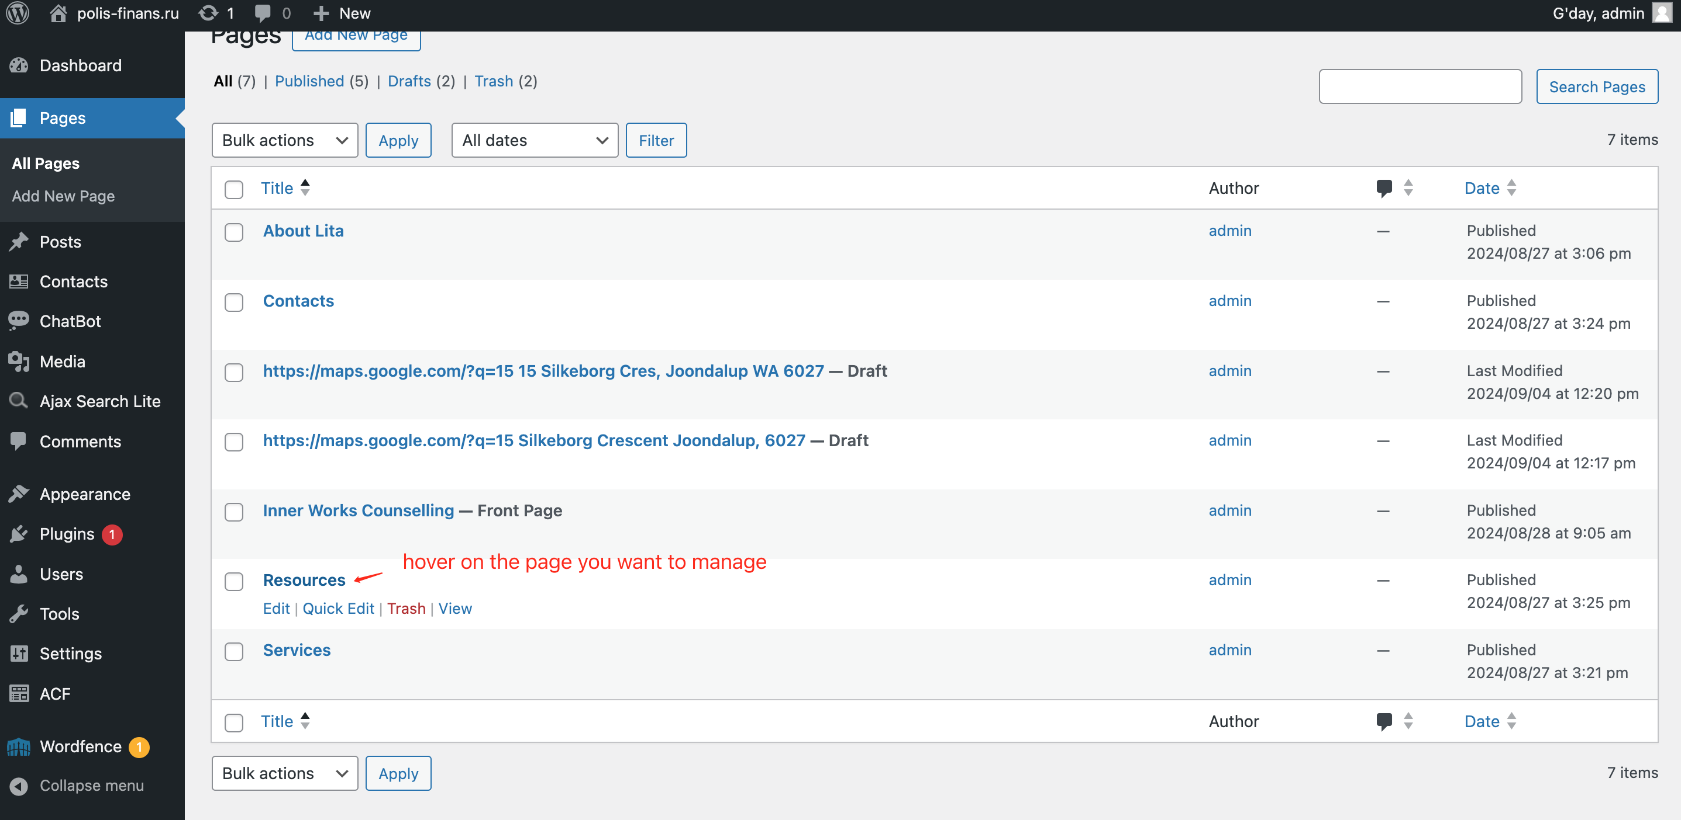

3. You'll be taken to the page editor.

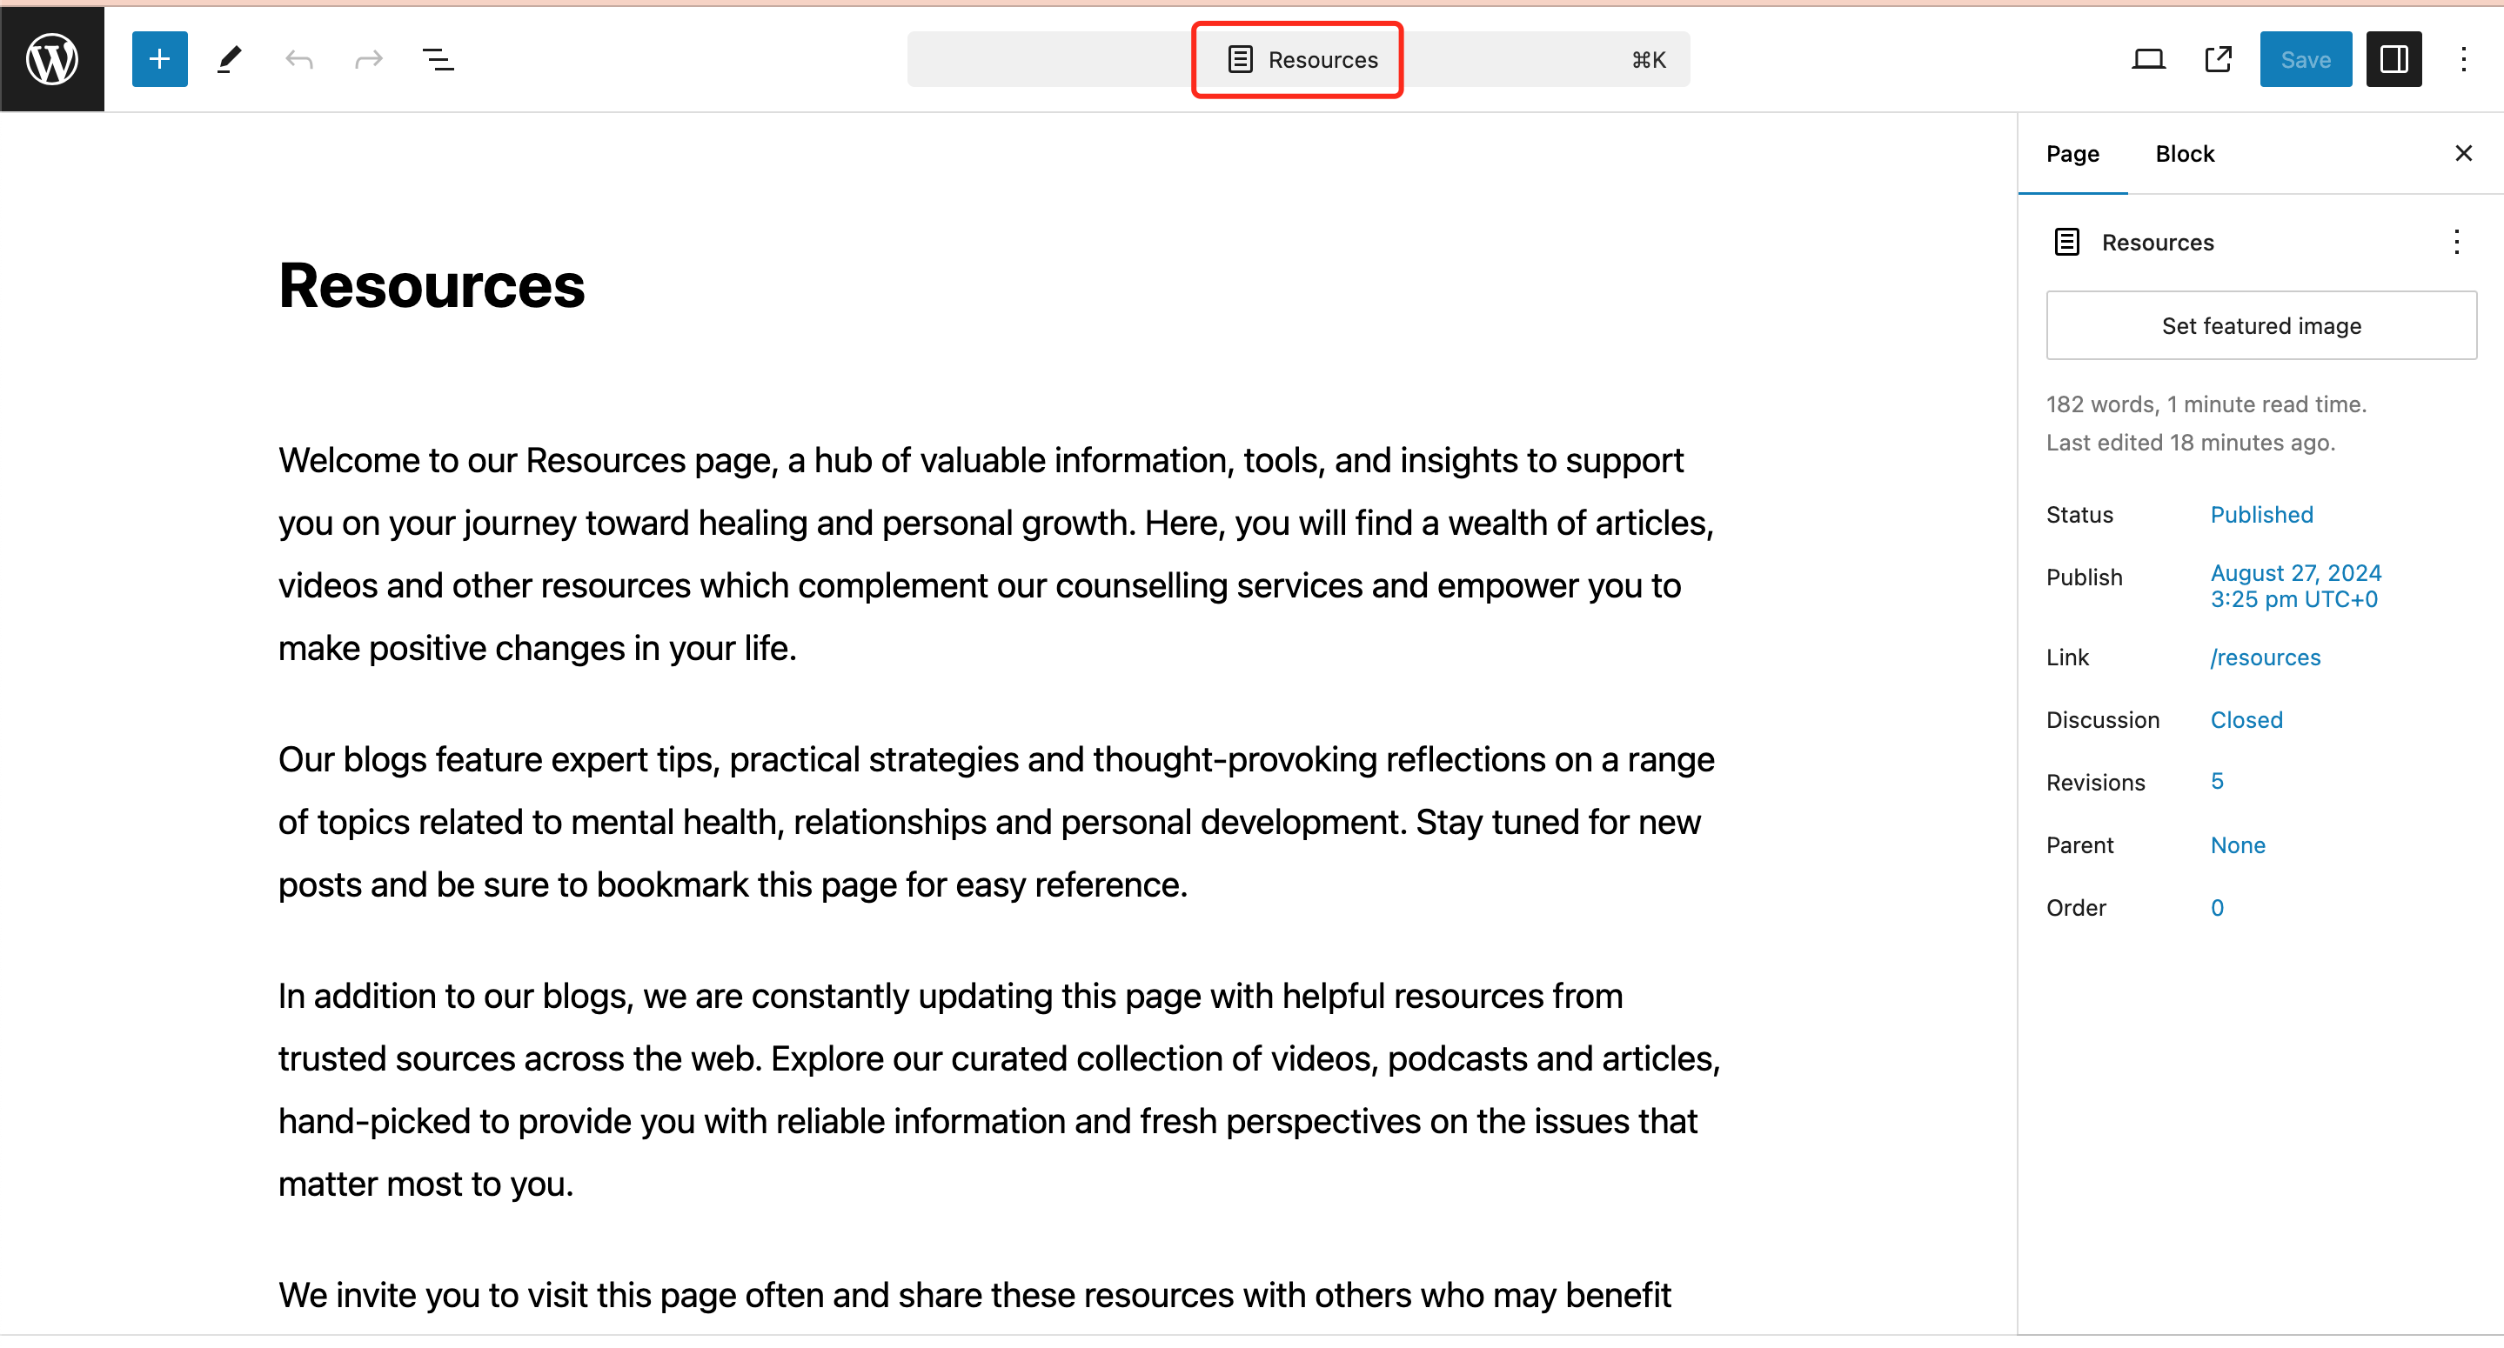

4. To change the title:

* Click on the "Resource" text at the top of the page.
* Type your new title to replace "Resources".

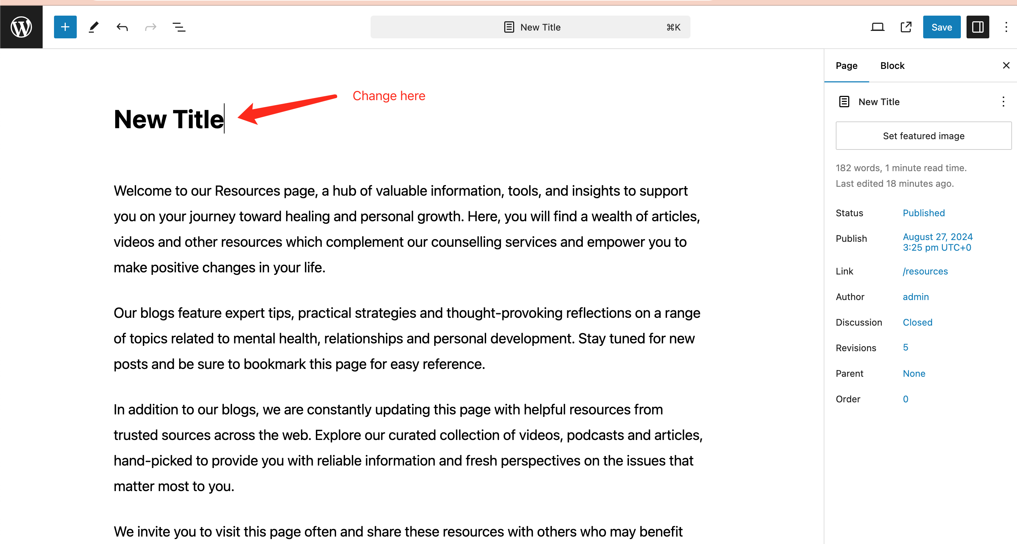

5. To edit the content:

* Click on the paragraph you want to modify.
* Use the text editing toolbar that appears above the paragraph to format your text (bold, italic, link, etc.)
* Type or paste your new content directly into the paragraph block.

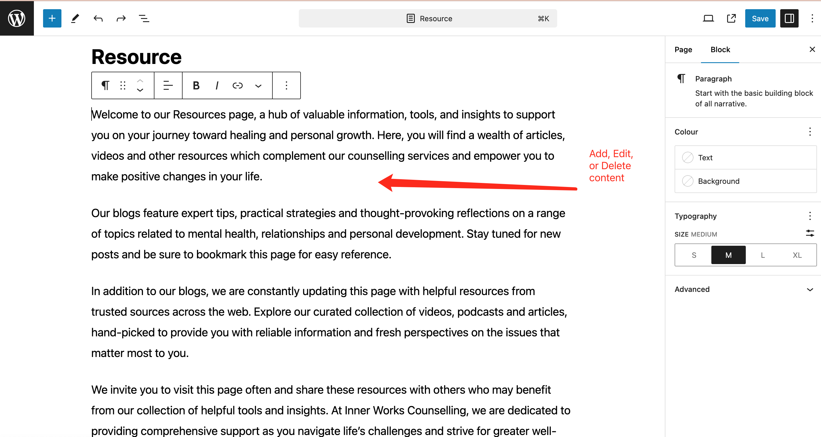

6. To add new content:

* Click the "+" icon at the top left of the editor to add new blocks (like paragraphs, headings, images, etc.)





7. To preview your changes, click the laptop icon in the top right corner. This opens a dropdown menu with several options:

* Desktop: Preview how the page looks on desktop screens.
* Tablet: Preview the page layout for tablet devices.
* Mobile: See how the page appears on mobile phones.
* Preview in new tab: Opens a full preview of the page in a new browser tab.

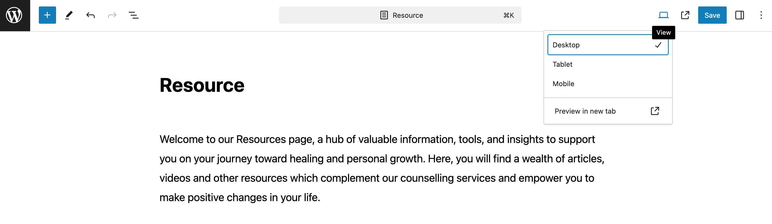

8. After previewing, click the "Save" button to publish your updates. Visit your website to verify the changes appear as intended.

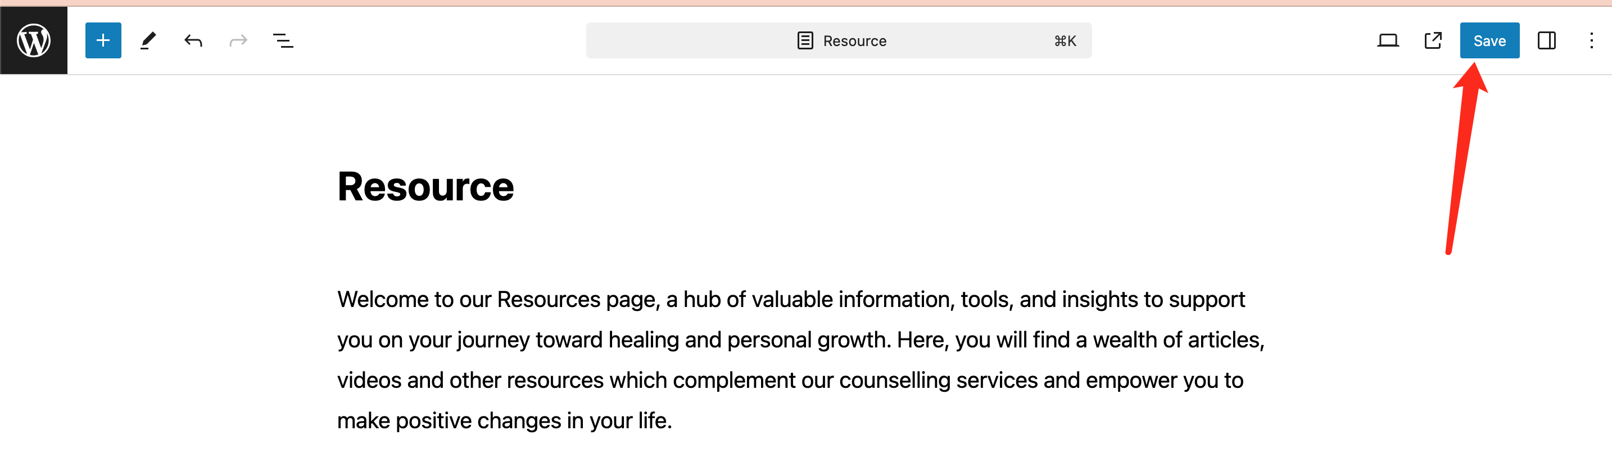

# How to Add, Edit and Delete a Resource

1. Open Posts page and click on the “Add a New Post”.

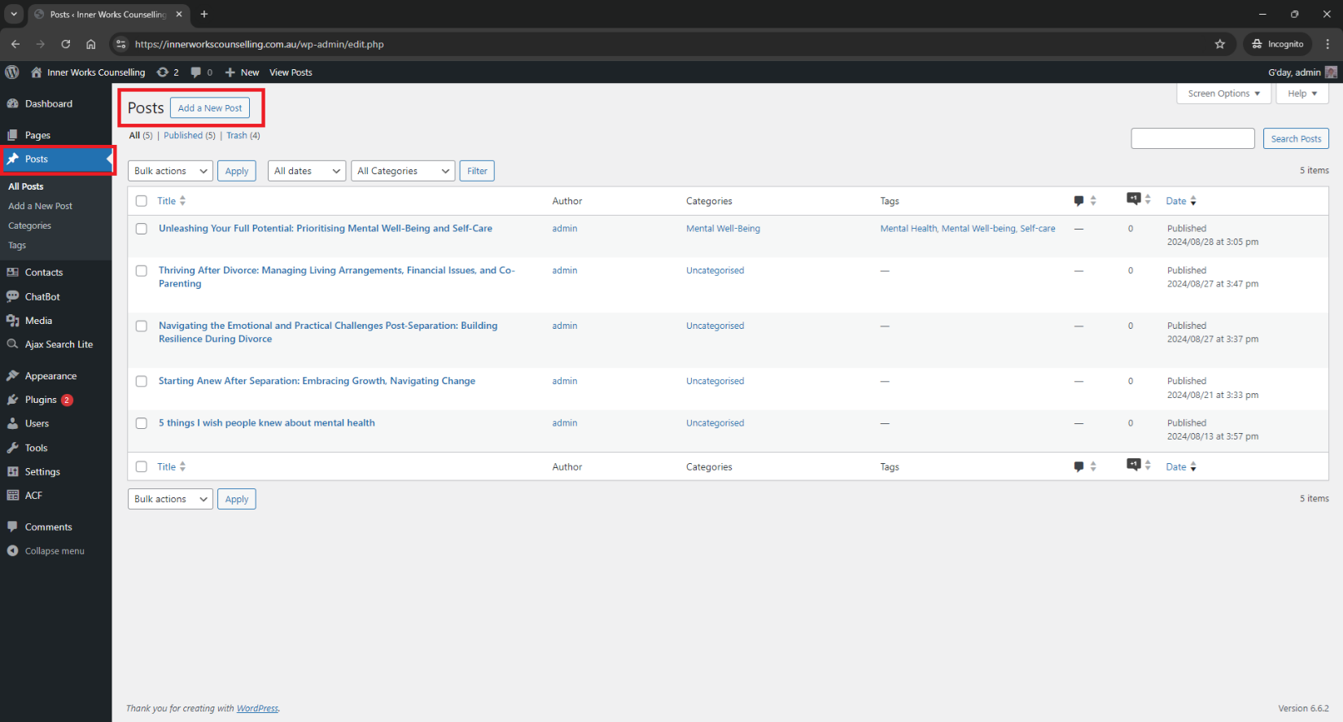

2. Add Title, add content and click the button “Publish”.

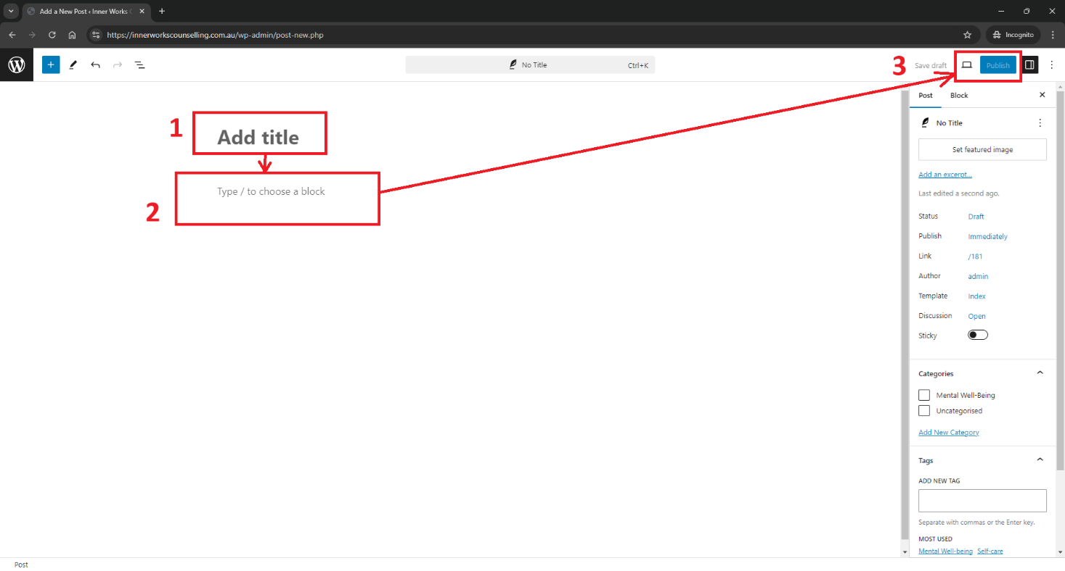

1. Select a resource, click the “Bulk actions” and choose Edit for editing selected resources or “Move to Trash” for deleting resources. You can also edit a resource by clicking on the resource title.

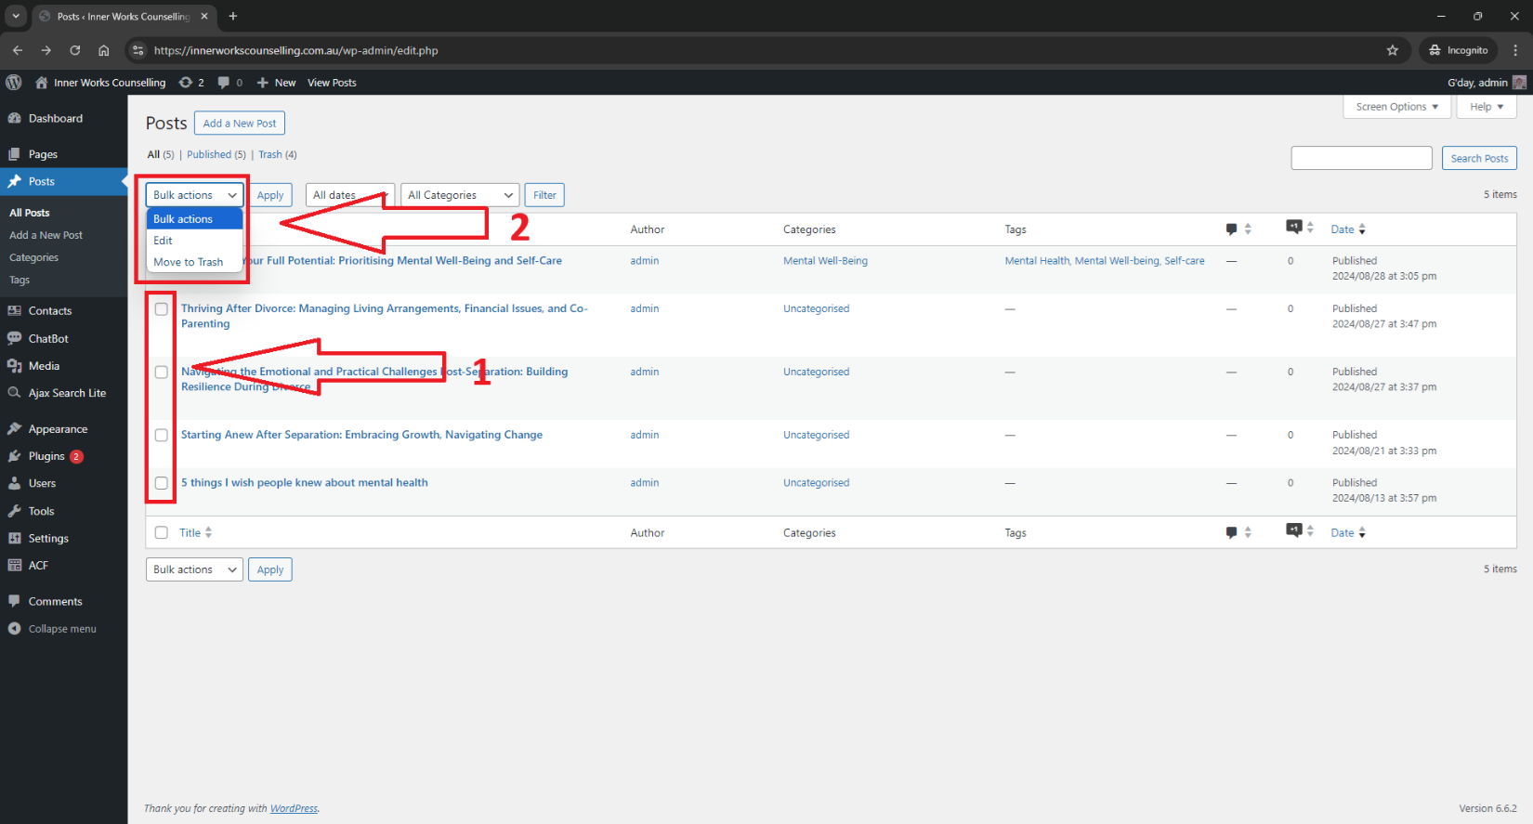

# How to Edit the Contacts Page Content

**1. Log in to WordPress Admin Panel and Navigate to Pages**

Log in to your WordPress admin dashboard. In the left sidebar menu, click on "Pages – All Pages".



**2. Locate and Edit ‘Contacts’ Page**

On the Pages screen, locate the "Contacts" page in the list of pages. Hover your mouse over the " Contacts" page title and click "Edit" when it appears.

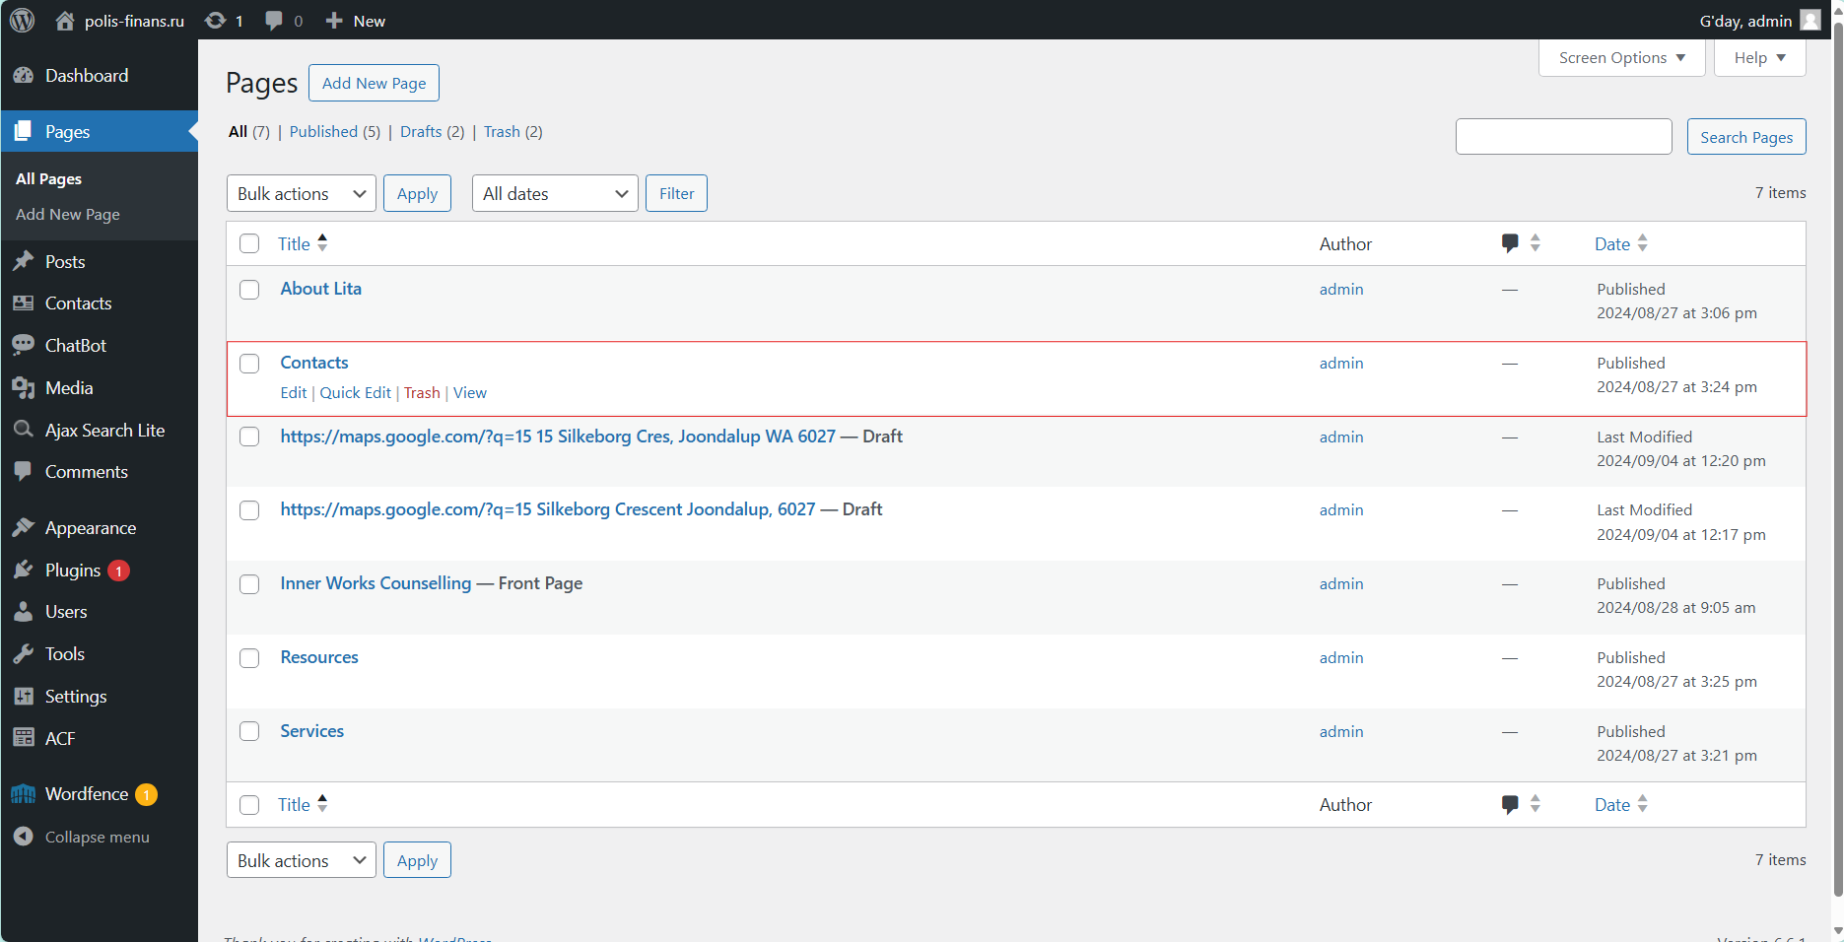

**3. Edit / Add Content Existing Fields**

The page editor will allow you to change the following fields:

* **Title**: Change the title by editing the text in the title field at the top.
* **Custom Fields:** The page uses custom fields to display information like the phone number, address, and counseling hours. To modify these values, you'll need to modify directly in the panel below the content.

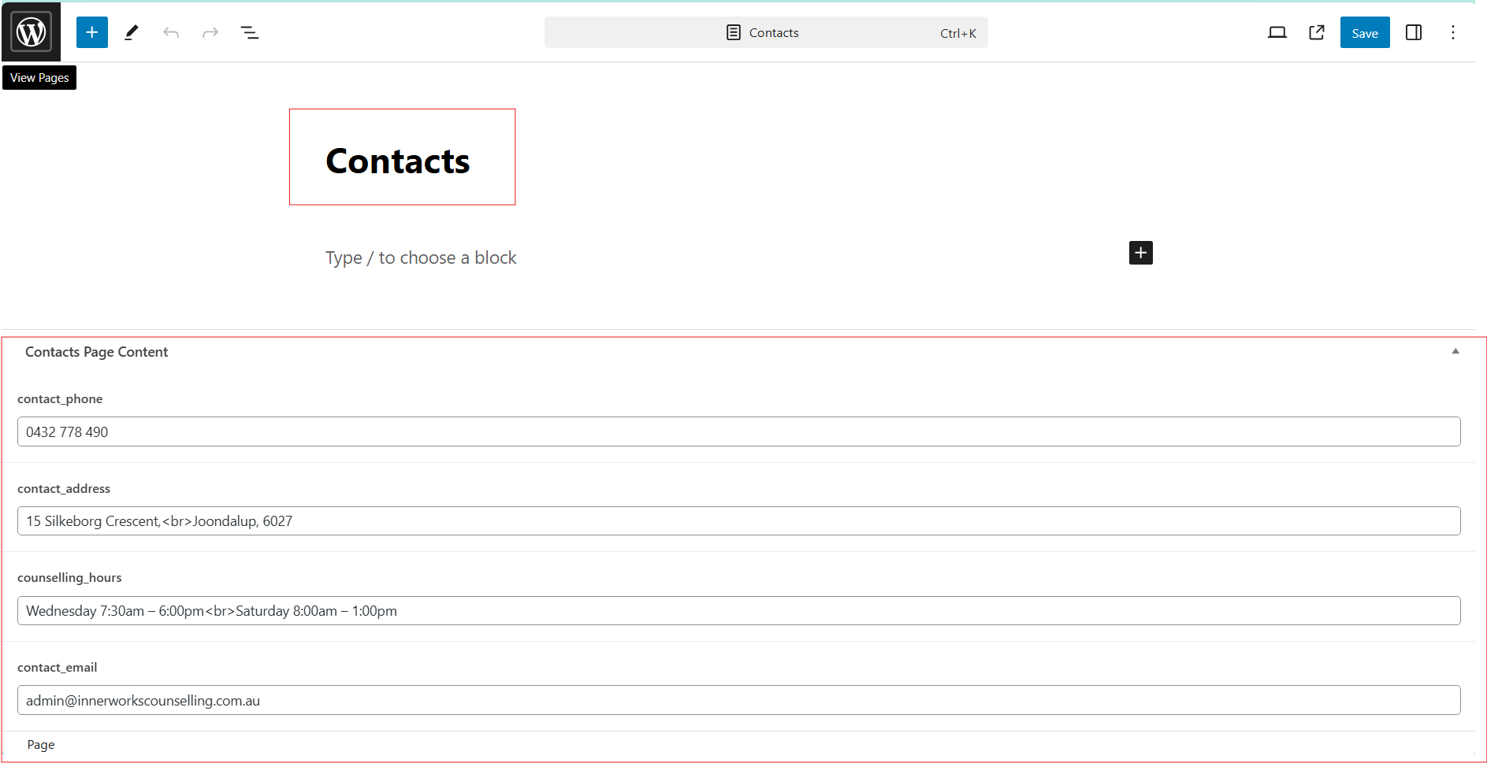

**4. Edit the content**

* The title is editable using the text editing toolbar that appears above the paragraph to format your text (bold, italic, link, etc.)
* Type or paste your new content directly into the paragraph block.
* Custom fields can be modified by locating the sections you want to modify and editing the text directly. For example, to change the phone number, find the line ('contact_phone') and replace the content with the new phone number.

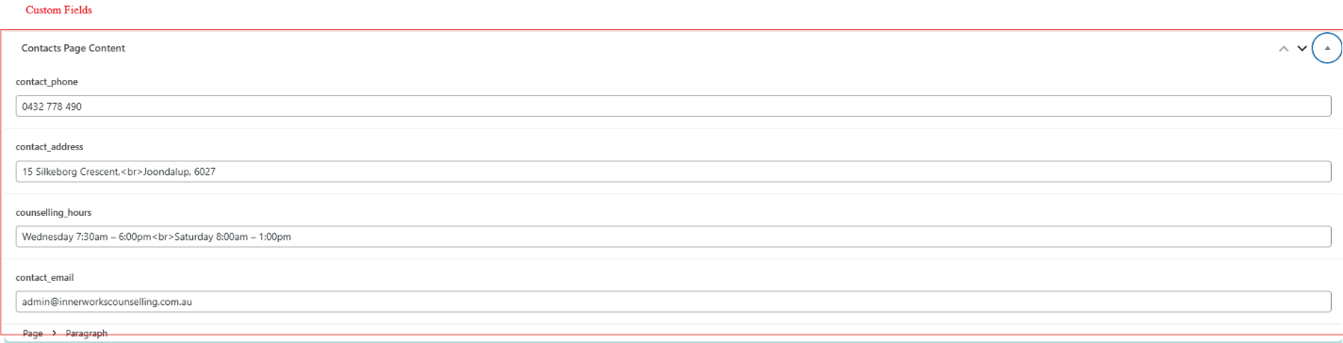

**5. Add new content**

* Click the "+" icon at the top left of the editor to add new blocks (like paragraphs, headings, images, etc.)



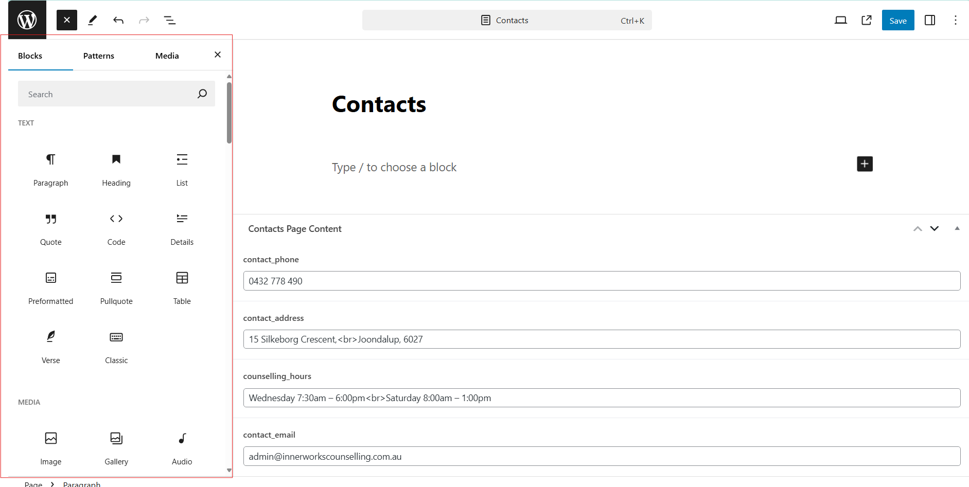

**6. Preview and Save Changes**

To preview your changes, click the laptop icon in the top right corner. This opens a dropdown menu with several options:

* Desktop: Preview how the page looks on desktop screens.
* Tablet: Preview the page layout for tablet devices.
* Mobile: See how the page appears on mobile phones.
* Preview in new tab: Opens a full preview of the page in a new browser tab.

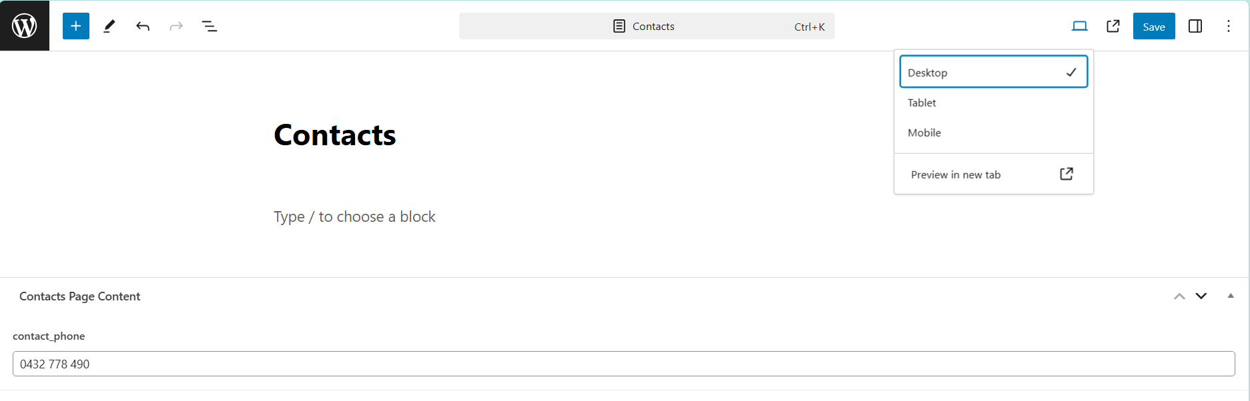

After previewing, click the "Save" button to publish your updates. Visit your website to verify the changes appear as intended.

**7. Rollback**

If you are not happy with your changes or you want to undo or redo changes, there is a edit panel bar in the left side of the page with tools such as:



* Tools: Tools provide different interactions for selecting, navigating, and editing blocks. Toggle between select and edit by pressing Escape and Enter.
* Undo
* Redo
* Document Overview

Note: if you want to just quit without saving, just click on the WordPress Icon and confirm you want to not save your changes.



# Chat bot

**1. Login and Access Settings**

* After logging into the system, navigate to the **Chatbot** section.
* Locate the **Settings** option. This allows you to configure various aspects of the chatbot’s behaviour and appearance.

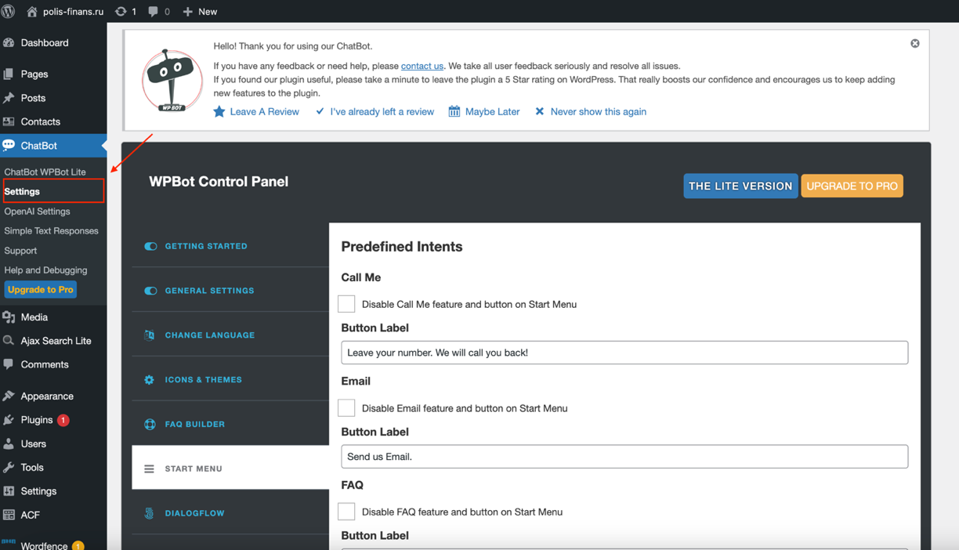

**2. Updating Email Address for queries received via chatbot**

* To change the email address associated with the chatbot, go to the **Settings** page.
* Locate the **General Settings** section. You can update the email address used for receiving inquiries via the chatbot, as well as the address from which inquiry responses will be sent. (might appear in junk sometimes)

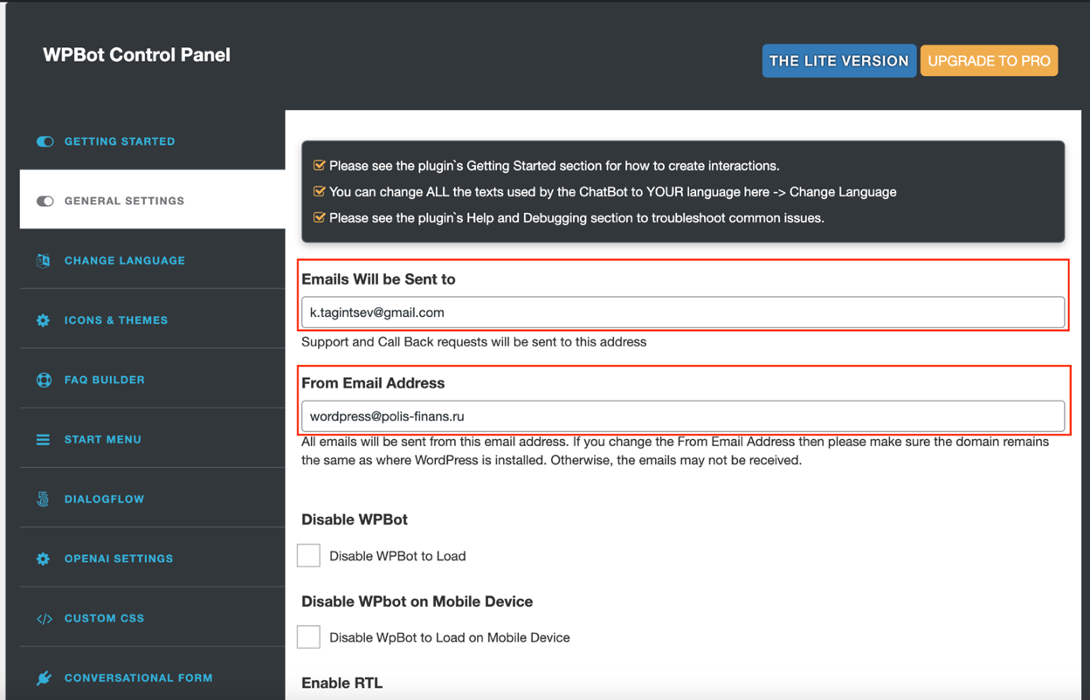

**3. Customizing Initial Greeting and Common Phrases**

* You can personalize the chatbot’s responses by modifying the messages.
* Under the **Change Language** section, input your custom greeting. This message will be displayed when a user interacts with the chatbot for the first time.
* Customize **Commonly Occurring Phrases** to match the tone or branding of your website or service. These include phrases frequently used during user interactions.

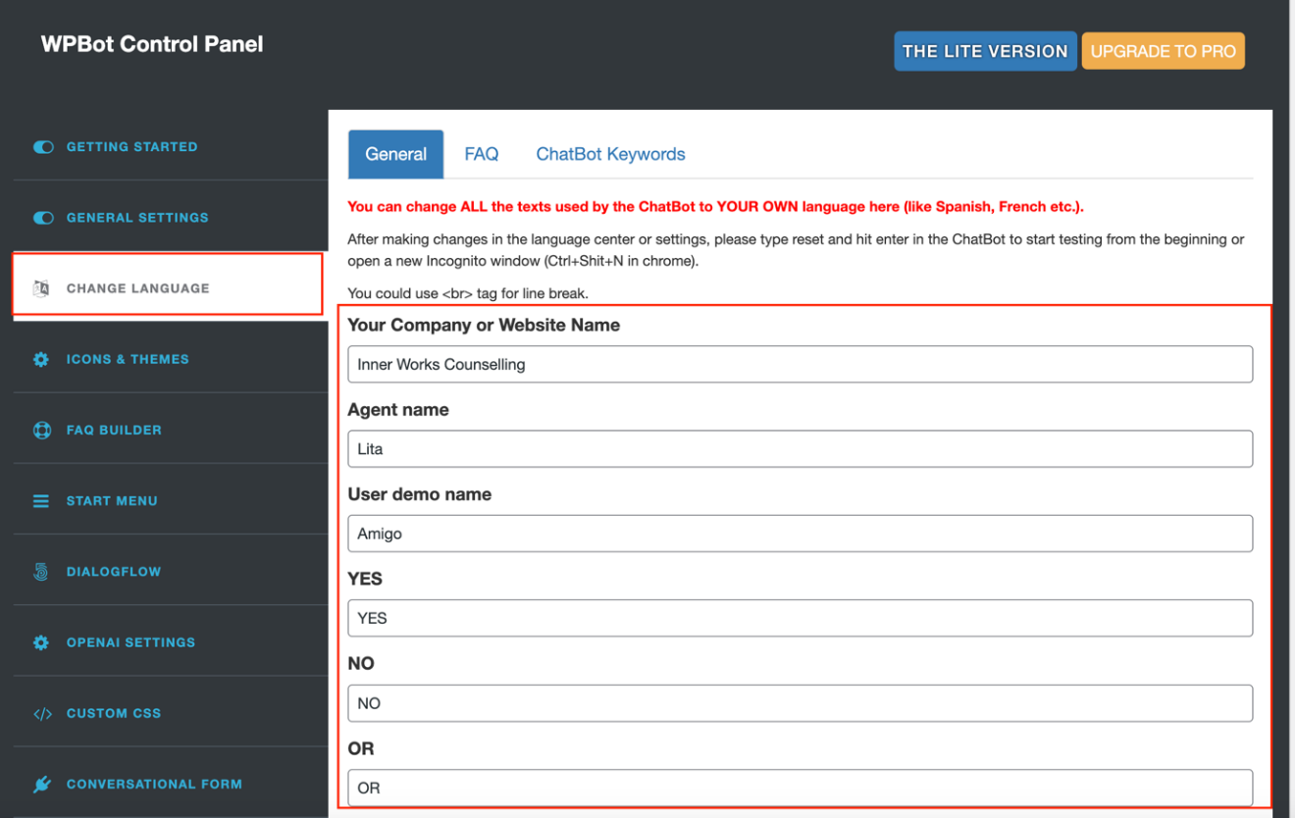

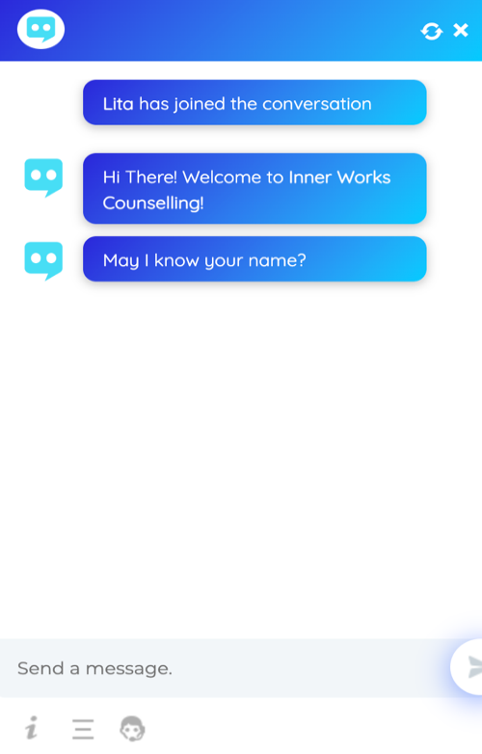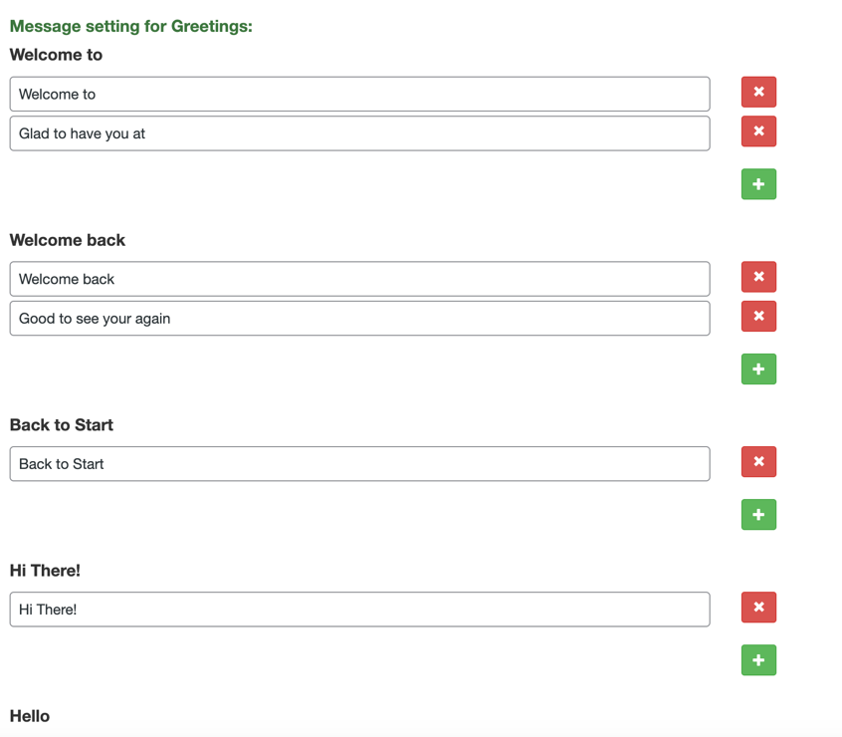

**4. Personalizing the Chatbot Icon and Themes**

* In the **Icon & Themes**, you can change the visual representation of your chatbot.

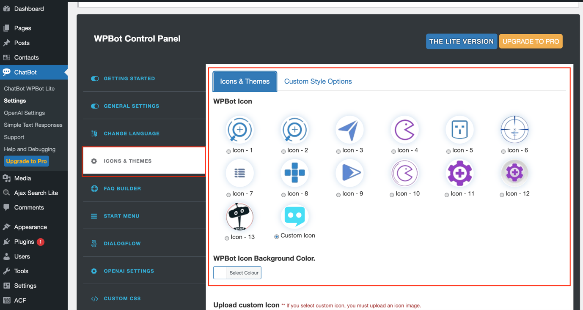

**5. Building and Customizing an FAQ Section**

* The **FAQ Builder** allows you to create a tailored list of frequently asked questions for the chatbot.
* Scroll down to the bottom of the **FAQ Section** to add more questions and answers.

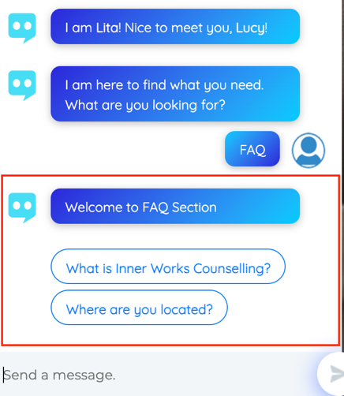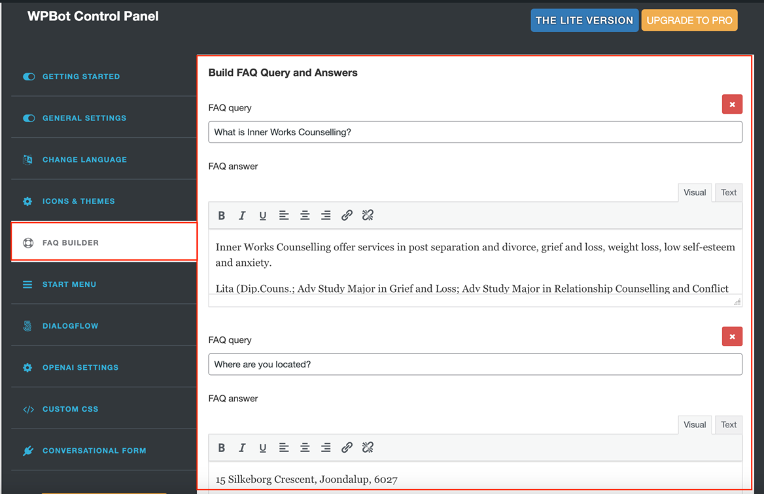

# Contacts table

1. Open the Contacts page, where all contacts from visitors are stored, to add, edit, delete, or export contacts: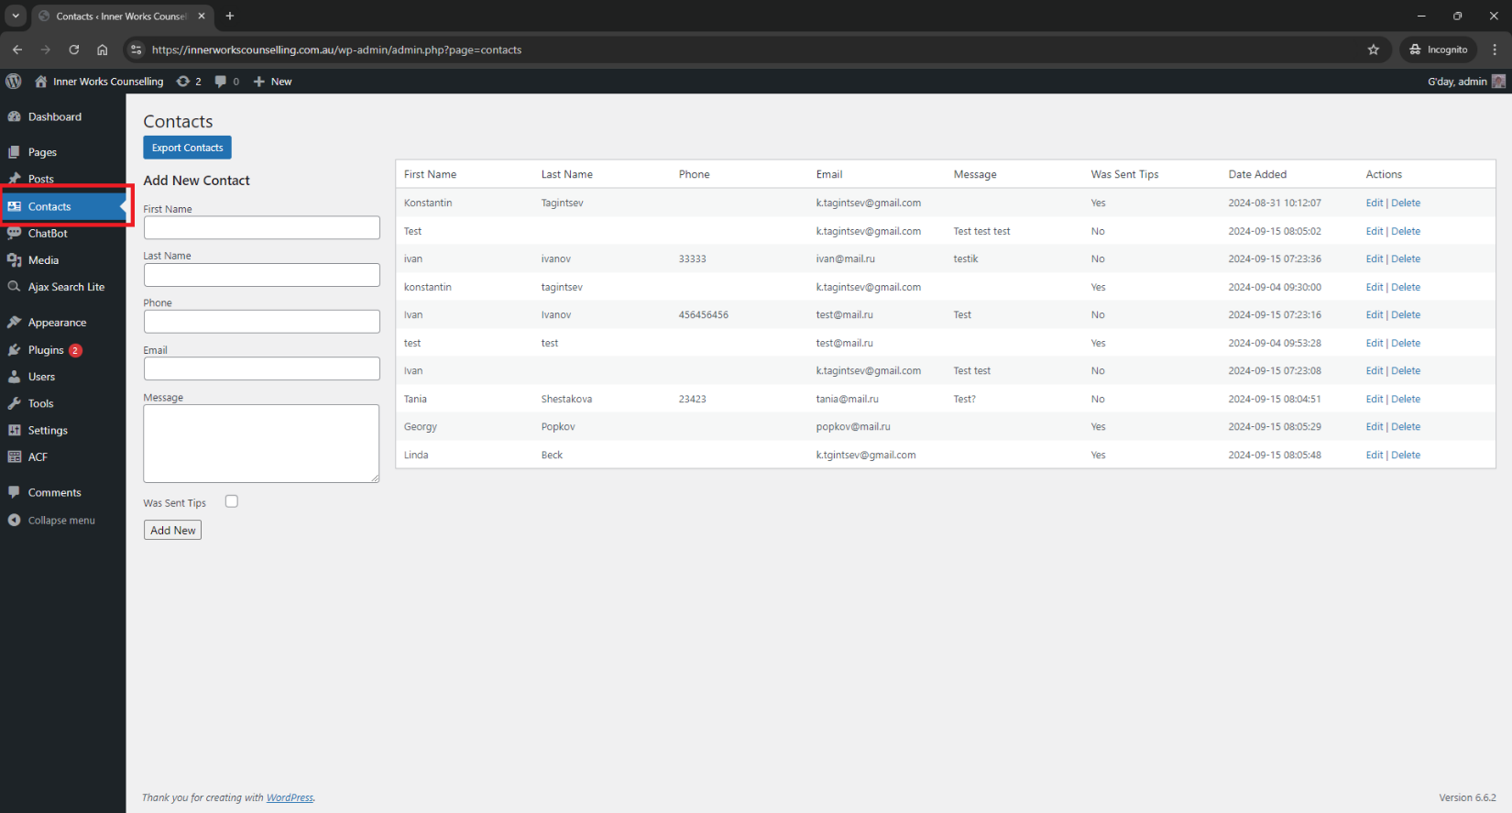

2. Add a contact:

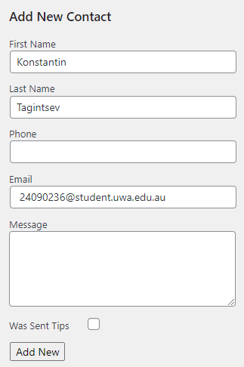

3. Edit/delete a contact:

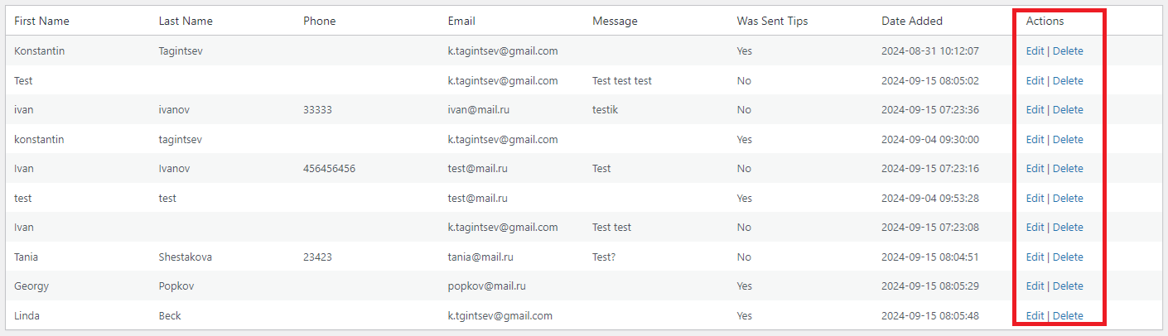

4. Export contacts:

